BIRTH PREFERENCES

Name

Estimated Due Date

Our aim is to have a natural birth at the……, with as little intervention as possible. We would like a positive and life-enhancing experience with no fear.
We plan to use…..techniques to focus on remaining calm and relaxed and appreciate your support in achieving a calm and comfortable environment.
Symbols can be downloaded for free: https://www.pinterandmartin.com/vbp
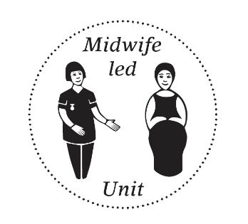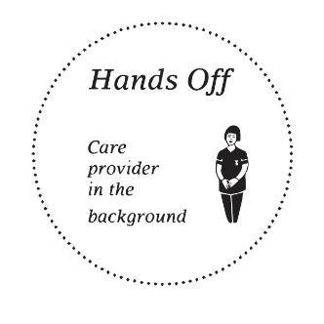
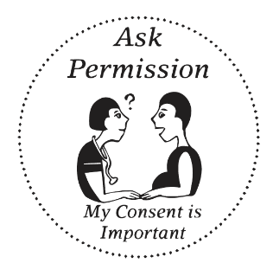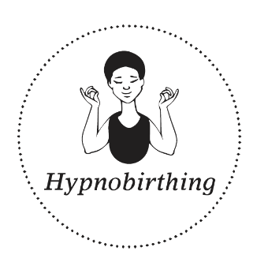

BEFORE LABOUR BEGINS / EARLY STAGES
- If I go past my due date and baby and I are fine, I prefer to go into labour naturally rather than be induced.
- I prefer no/ minimal internal vaginal exams.
- Please do not inform me of my cervix dilation
- I prefer not to have my membranes broken unless there is an emergency situation.
- I would prefer to stay at home as long as possible in the early stages of labour


ENVIRONMENT
- I would like to be able to dim the lights and arrange the room as I wish.
- I would like to keep the minimal number of people in the room with me at any one time.
- I would prefer any non-specific labour and birth questions be directed at my birth partner or doula
- I would like care provider’s conversations to be kept to a minimal volume.
- Please don’t use the word ‘pain’, I prefer ‘sensations’ or ‘intense feeling’
- I would like to play music.
- I would like to keep active during labour.
- I would like to be in the water when in labour and for the birth if possible.
- Please don't say Failure to Progress. Please say Slow Labour

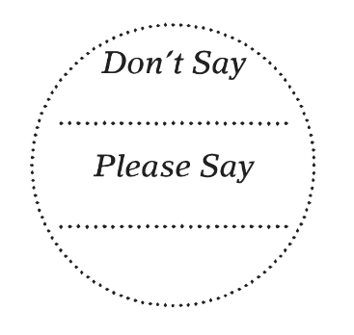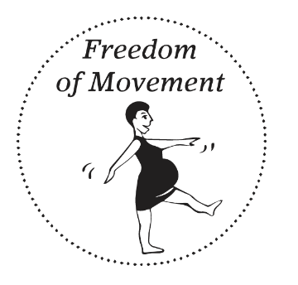

MONITORING/EXAMINATIONS
- I would like to have as much of an undisturbed birth as possible, with minimal monitoring and vaginal examinations.
- I would prefer any necessary monitoring to be done with a Doppler.

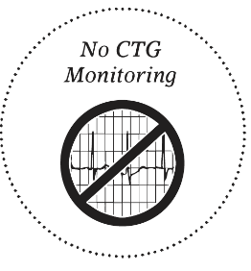

PAIN RELIEF / INTERVENTIONS
- I would like to avoid the use of medication and would prefer not to be offered pain relief, unless asked for specifically three times within an hour
- I would prefer any other interventions such as forceps, ventouse, caesarean, not to be used, except as an absolute last resort.
- I would like to exercise patience if my labour pauses and use natural means to stimulate the process.
- I would like any suggested interventions explained fully and clearly, with time to discuss with my partner our choices before any decisions are made.
- I am happy to wait for things to progress naturally rather than try to rush the process unless my baby is in obvious distress. I will accept assistance if there is no other option.



BIRTHING PHASE
- During the birthing phase, I would like to use my body’s natural expulsive reflex to move my baby down, instead of forced pushing.
- As long as the baby and I are healthy, I prefer to have no time limits on pushing.
- I would prefer not to be coached during this time.
- I prefer not to have an episiotomy and any 1st degree tears left to heal naturally.
- I would like to be able to position myself in whichever way feels most comfortable to me.
- I would like to be in the pool at this time if possible.
- I would like my husband or I to catch my baby and pull it onto my abdomen as it is born.
- I would like immediate skin to skin with my baby whether we experience a natural or assisted delivery.
- I would like to delay clamping the cord until it has stopped pulsating.

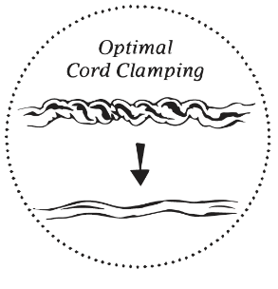

THIRD STAGE
- I would like to birth my placenta naturally, unless there is a clear medical need for me to have the injection.
- I would like to keep my placenta and take it home

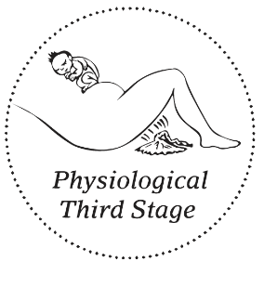

NEWBORN PROCEDURES
- I would like immediate skin to skin with my baby
- Please do not separate me and my baby unless there is a medical emergency until after my baby has successfully breastfed.
- Please delay all essential routine procedures on my baby, until after the bonding and breastfeeding period.
- I would like all newborn routine procedures to be performed in my presence.
- I would like the baby to remain with myself or my birth partner at all times.
- If the baby has any problems, I would like my partner to be present with the baby at all
- times, if possible.
- Please don’t put a hat on my baby.
- Please don’t wash or bath my baby.
- Please do not give my baby Vitamin K

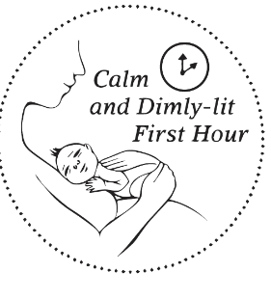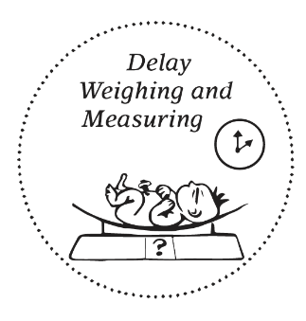
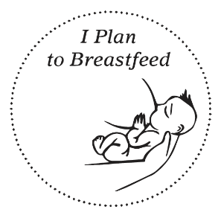

IN THE EVENT OF A CESAREAN. IF POSSIBLE I WOULD LIKE
- My partner to be present at all times during the c-section.
- Drapes lowered so I can see my baby being born.
- Drip in the non-dominant arm.
- ECG dots away from front of chest.
- Hospital gown on backwards for skin to skin.
- Slow and gentle birth of baby.
- Place baby directly onto my chest for skin to skin.
- Immediate breastfeeding in theatre unless there is an emergency
- Cord left to stop pulsing before cutting unless there is an emergency
- No weighing or measuring until we are ready.

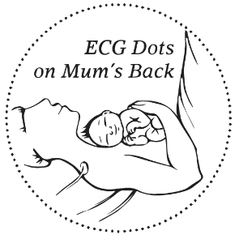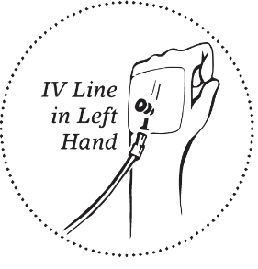


AFTERWARDS
- I would like the baby to remain with myself or my partner at all times.
- I prefer to have my partner with me during my stay and visitors to be kept to a minimum.
- I wish to exclusively breastfeed and hope that this process can begin naturally soon after birth. I would appreciate help and support to make this possible.

